**Do interspecific pollinator priority effects mediate fruit weight in different plant species with distinct floral structures?**

We detected a strong priority effect in blueberry, whereby fruit produced from flowers that received their first visit from a stingless bee were initially 87.27% heavier than those that had a honeybee visit first (Figure 1). However, with an increasing number of visits, weight of fruit produced from flowers that received honeybee visits first increased, whereas weight of fruit from flowers that received a stingless bee visit first decreased (honeybee – stingless bee slope contrast = 0.078 ± 0.027, *t* = 2.872, *P* = 0.0052; Figure 1).

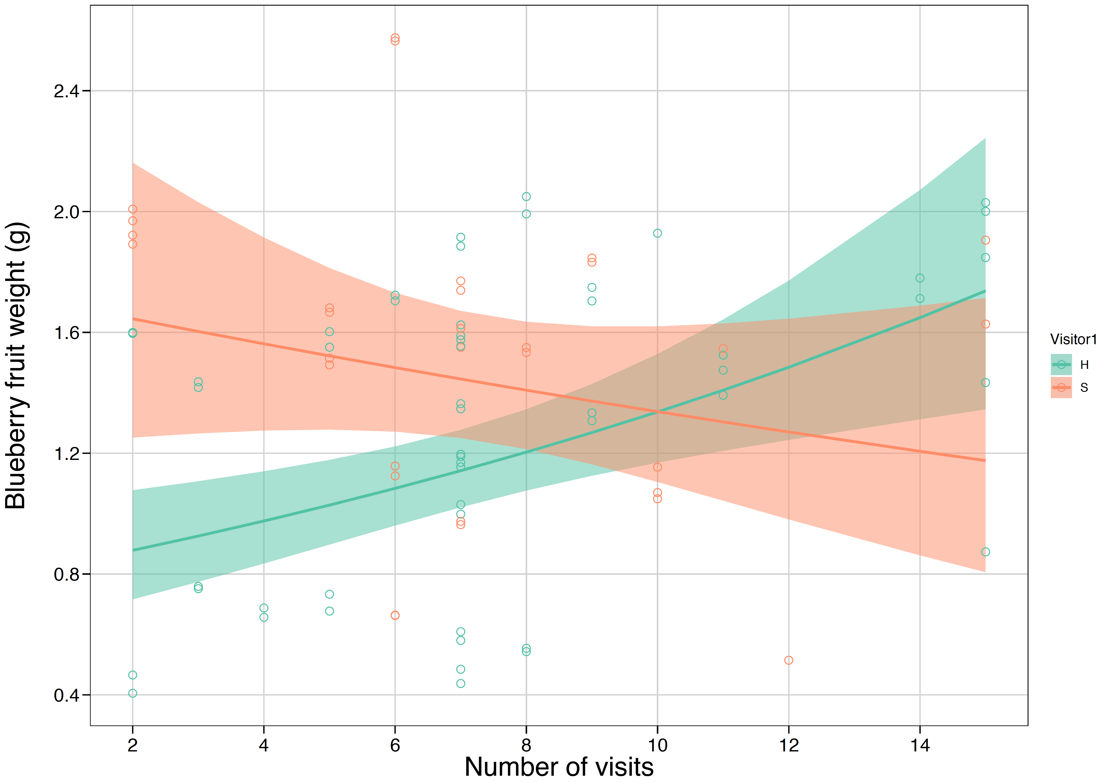

**Figure 1.** Weight of blueberry fruit from flowers first visited by a honeybee versus those first visited by a stingless bee. Solid lines are the model-estimated fruit weights with an increasing number of pollinator visits and shaded ribbons are the model-estimated confidence intervals. Hollow circles are the actual data.

However, we found no evidence of a pollinator priority effect in raspberry, where fruit weight was similar across the visit number range regardless of first visitor’s identity (honeybee – stingless bee slope contrast = 0.024 ± 0.035, *t* = 0.699, *P* = 0.48; Figure 2). The ratio of honeybee to stingless bee visits had no effect on fruit weight for both blueberry and raspberry.

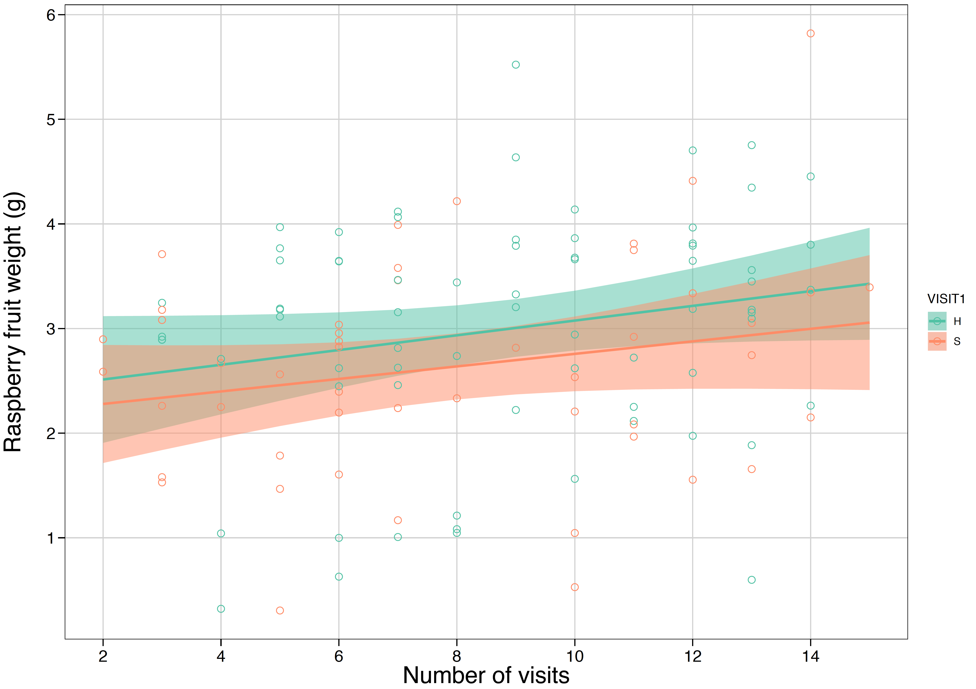

**Figure 2.** Weight of raspberry fruit from flowers first visited by a honeybee versus those first visited by a stingless bee. Solid lines are the model-estimated fruit weights with an increasing number of pollinator visits and shaded ribbons are the model-estimated confidence intervals. Hollow circles are the actual data.

**Does a mixture of floral visits from different pollinator species result in heavier fruits than visits from a single species?**

For blueberry, we found that fruit weight increased with an increasing number of visits from honeybees (slope = 0.108 ± 0.047, *z* = 2.285, *P* = 0.0118; Figure 3) and stingless bees combined with honeybees (slope = 0.028 ± 0.015, *z* = 1.852, *P* = 0.0329) but not for stingless bees only (slope = -0.029 ± 0.079, *z* = -0.385, *P* = 0.6496).

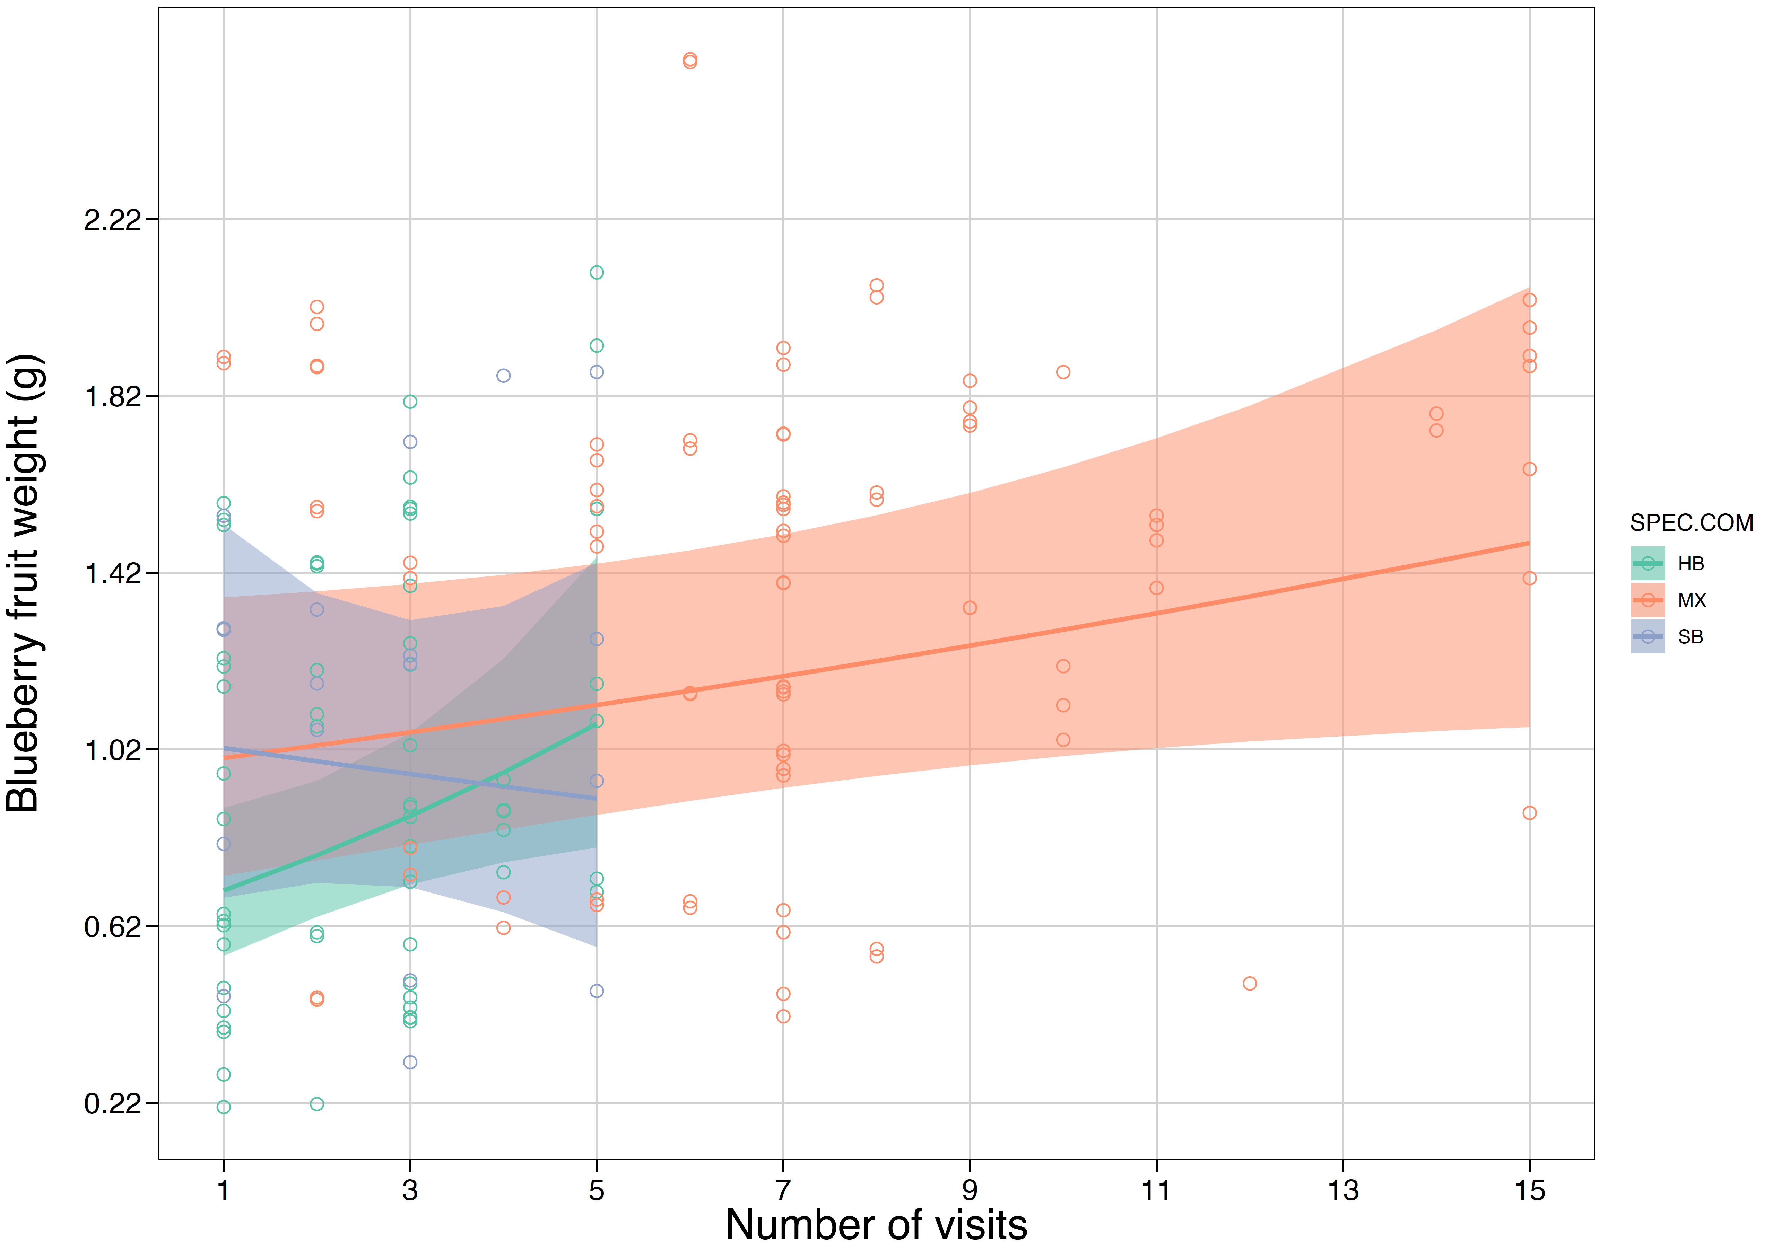

**Figure 3.** Weight of blueberry fruit from flowers visited by only honeybees or stingless bees or a mixture of honeybees and stingless bees. Solid lines are the model-estimated fruit weights with an increasing number of pollinator visits and shaded ribbons are the model-estimated confidence intervals. Hollow circles are the actual data.

In contrast, for raspberry, we found that fruit weight increased with an increasing number of visits from stingless bees (slope = 0.178 ± 0.069, *z* = 2.559, *P* = 0.006; Figure 4) and stingless bees combined with honeybees (slope = 0.043 ± 0.016, *z* = 2.657, *P* = 0.0042) but not from honeybees only (slope = 0.026 ± 0.029, *z* = 0.886, *P* = 0.1883).

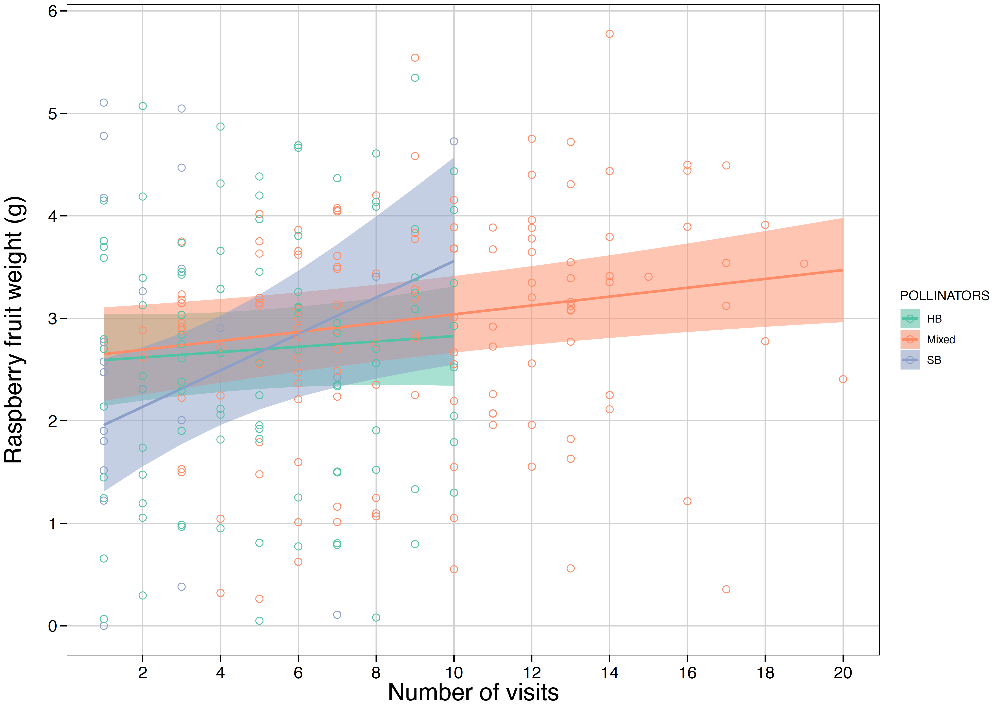

**Figure 4.** Weight of raspberry fruit from flowers visited by only honeybees or stingless bees or a mixture of honeybees and stingless bees. Solid lines are the model-estimated fruit weights with an increasing number of pollinator visits and shaded ribbons are the model-estimated confidence intervals. Hollow circles are the actual data.

Despite these trends, for both raspberry and blueberry we found no differences between slopes (association between fruit weight and the number of pollinator visits) for fruits produced from stingless bee versus honeybee visits. Similarly, there were no differences between slopes for fruits produced from a mixture of stingless bee and honeybee visits versus visits from either one of these taxa (Table SX).